HILLY FIELDS MIDSUMMER FAYRE 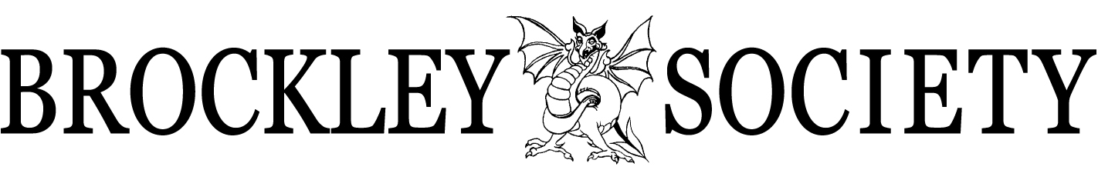
www.brockleysociety.org.uk

Saturday 25 June 2022, 12 - 5pm

STALL BOOKING APPLICATION FORM
THIS APPLICATION FORM IS NOT FOR CATERING STALLS
IMPORTANT - please first read the information sheet *** YOU CAN EMAIL YOUR APPLICATION***
RETURN YOUR FORM NO LATER THAN Monday 20 June 2022
PAYMENT NO LATER THAN Thursday 23 June 2022
Please complete all sections of the application form in BLOCK LETTERS

Stall name (to go on your invoice)

Your name (if different)

Please note: For environmental reasons we will not allow helium balloons or “Silly String” to be sold.
Please give a brief description of what you plan to sell on the day:
Tick which category you want to be placed in:
1) Community & Services (C&S) 2) Arts & Crafts (A&C)
3) Bric-à-Brac (BB) 4) Food-related (F) (NO catering or cake stalls)
*Mandatory contact information. We will adhere to GDPR guidelines with you personal data.
Contact Name*
Postal Address*
Email Address* | Telephone / Mobile*

I/we have read and agree to abide by the conditions on the INFORMATION SHEET

Signed Date:
 | NOTE: No tables or chairs are provided for outdoor pitches |  | £ each | How many? | Cost
 | Single outdoor pitch | approx 3m wide x 3m deep | £25 | x = | £
 | Double outdoor pitch | approx 6m wide x 3m deep | £50 | x = | £
 | Marquee Stall (Arts & Crafts only) | one 6ft table & chair included | £45 | x = | £
EMAIL applications to: stalls@brockleysociety.org.uk

The Fayre is organised entirely by volunteers. Please be patient
and give us time to process your application. Thank you!

 | Brockley Society, PO Box 63473, London SE4 9AZ

